***PROJECT REPORT***

***ON***

***VIDEO SHARING APP(YOU TUBE CLONE) MERN***

***A Project Report Submitted in Partial fulfillments of Requirements for the Award of the Degree***

***in***

***Bachelor of technology in***

***Computer science engineering***

***Submitted to***

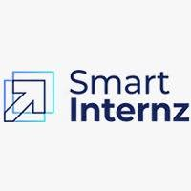

***Submitted by***

**TEAM ID : LTVIP2024TMID05452**

**TEAM LEAD : CHUNDURU SOMBABU**

**TEAM MEMBERS: 1)Boyapati Prasanth**

**2)Prasadam Tejaramkrishna**

**3)Chadalawada Satwik**

* **INTRODUCTION:**

In today's digital age, video content has become one of the most popular and engaging forms of media consumption. From entertainment to education, people across the globe are increasingly turning to video sharing platforms to discover, watch, and share a wide range of content. With the proliferation of high-speed internet and mobile devices, the demand for video sharing applications has never been higher.

A Video Sharing App built using the MERN stack (MongoDB, Express.js, React.js, and Node.js) presents an innovative and scalable solution to meet this growing demand. By leveraging the power of these cutting-edge technologies, developers can create a feature-rich platform that empowers users to upload, discover, and interact with video content seamlessly.

This introduction will explore the key components and features of a Video Sharing App developed using the MERN stack, highlighting its benefits and potential impact on the digital media landscape. We'll delve into the architecture, user experience, and functionalities that make such an app a compelling and versatile tool for content creators, viewers, and communities alike.

* **LITERATURE SURVEY:**

A literature survey on a Video Sharing App using the MERN stack would involve exploring existing research, articles, and publications related to similar projects or technologies. Here's how you can conduct a literature survey on this topic:

1. **Identification of Relevant Keywords**:
   * Begin by identifying keywords related to video sharing apps, MERN stack development, and relevant technologies such as MongoDB, Express.js, React.js, and Node.js.
2. **Search in Academic Databases**:
   * Utilize academic databases like PubMed, IEEE Xplore, ACM Digital Library, and Google Scholar to search for research papers, conference proceedings, and articles related to video sharing platforms and MERN stack development.
   * Use combinations of keywords to narrow down search results, such as "video sharing app development," "MERN stack architecture," "user engagement in video platforms," etc.
3. **Review of Research Papers**:
   * Look for research papers that discuss the design, development, and user experience aspects of video sharing apps built using the MERN stack or similar technologies.
   * Pay attention to methodologies, findings, challenges, and recommendations presented in these papers, as well as any insights into user behavior and engagement patterns.
4. **Exploration of Online Resources**:
   * Explore online platforms, forums, and communities where developers and researchers discuss projects related to video sharing apps and MERN stack development.
   * Websites like GitHub, Stack Overflow, and developer forums might provide insights into practical implementations, code samples, and best practices.
5. **Analysis of Case Studies**:
   * Look for case studies or project reports that detail the implementation of video sharing apps using the MERN stack.
   * Examine the architecture, features, performance metrics, and user feedback presented in these case studies to gain insights into successful implementations and lessons learned.
6. **Evaluation of Technical Documentation**:
   * Review technical documentation, tutorials, and guides related to building applications with the MERN stack.
   * Platforms like Medium, Dev.to, and official documentation websites for MongoDB, Express.js, React.js, and Node.js may contain articles or tutorials relevant to video sharing app development.
7. **Summarization and Synthesis**:
   * Summarize key findings, insights, and trends observed across the literature.
   * Identify common challenges, innovative approaches, and areas for further research or improvement in the development of video sharing apps using the MERN stack.
8. **Critical Analysis and Comparison**:
   * Critically analyze the strengths and weaknesses of existing approaches to building video sharing apps with the MERN stack.
   * Compare different methodologies, technologies, and frameworks used in similar projects, and evaluate their impact on user engagement, scalability, and performance.
9. **Gap Identification**:
   * Identify gaps or areas where existing literature falls short in addressing specific aspects or challenges related to video sharing app development using the MERN stack.
   * Determine potential research opportunities or areas for innovation based on the identified gaps.
10. **Recommendations and Future Directions**:
    * Based on the literature review, provide recommendations for future research directions, potential improvements, and areas of innovation in developing video sharing apps using the MERN stack.
    * Consider the evolving landscape of digital media consumption, emerging technologies, and user preferences in shaping the future of video sharing platforms.

By following this structured approach, you can conduct a comprehensive literature survey on a Video Sharing App using the MERN stack, gathering valuable insights and informing the development of your own project or research.

* **THEORITICAL ANALYSIS:**

A theoretical analysis of a video sharing app using the MERN stack involves examining the underlying principles, concepts, and frameworks that guide its development and operation. Here's a breakdown of key theoretical aspects to consider:

1. **System Architecture**:
   * Describe the overall architecture of the video sharing app, including frontend (React.js), backend (Node.js with Express.js), and database (MongoDB).
   * Discuss how the MERN stack facilitates the development of a scalable and responsive platform for uploading, storing, and streaming video content.
2. **Data Modeling and Storage**:
   * Explore data modeling strategies for storing video metadata, user profiles, comments, likes, and other relevant information in MongoDB.
   * Discuss schema design considerations, indexing, and data relationships to optimize performance and scalability.
3. **Content Delivery**:
   * Analyze content delivery mechanisms for efficiently streaming video content to users, including adaptive bitrate streaming, caching, and content distribution networks (CDNs).
   * Evaluate the impact of latency, bandwidth, and network conditions on user experience and content delivery performance.
4. **User Authentication and Authorization**:
   * Discuss authentication and authorization mechanisms for securing user accounts, managing access control, and protecting sensitive content.
   * Explore strategies for implementing features such as user registration, login, password reset, and role-based permissions.
5. **User Experience (UX)**:
   * Evaluate user interface design principles for creating intuitive, engaging, and accessible user experiences in the video sharing app.
   * Discuss usability testing methodologies, user feedback mechanisms, and iterative design processes for optimizing UX.
6. **Social Interaction Features**:
   * Analyze social interaction features such as likes, comments, shares, and subscriptions, and their impact on user engagement and retention.
   * Explore algorithms for personalized content recommendations, discovery, and social networking within the app.
7. **Scalability and Performance**:
   * Discuss scalability considerations for handling increasing numbers of users, video uploads, and concurrent video streams.
   * Evaluate performance optimization techniques such as horizontal scaling, load balancing, and caching to ensure responsiveness and reliability under heavy load.
8. **Video Processing and Encoding**:
   * Explore video processing and encoding workflows for transcoding uploaded videos into different formats, resolutions, and bitrates.
   * Discuss integration with third-party video processing services and tools for tasks such as transcoding, thumbnail generation, and video analysis.
9. **Monetization Strategies**:
   * Analyze monetization strategies such as advertising, subscription models, pay-per-view, and premium content offerings for generating revenue from the video sharing app.
   * Evaluate the impact of monetization strategies on user experience, content quality, and platform sustainability.
10. **Legal and Regulatory Compliance**:
    * Discuss legal and regulatory considerations related to copyright, intellectual property rights, privacy, and data protection in the context of video sharing platforms.
    * Explore compliance requirements such as the Digital Millennium Copyright Act (DMCA), General Data Protection Regulation (GDPR), and Children's Online Privacy Protection Act (COPPA).

By conducting a theoretical analysis of a video sharing app using the MERN stack, you can gain insights into the fundamental principles, challenges, and best practices involved in designing and operating such a platform. This theoretical foundation can inform decision-making, guide architecture design, and facilitate the development of a successful video sharing app.

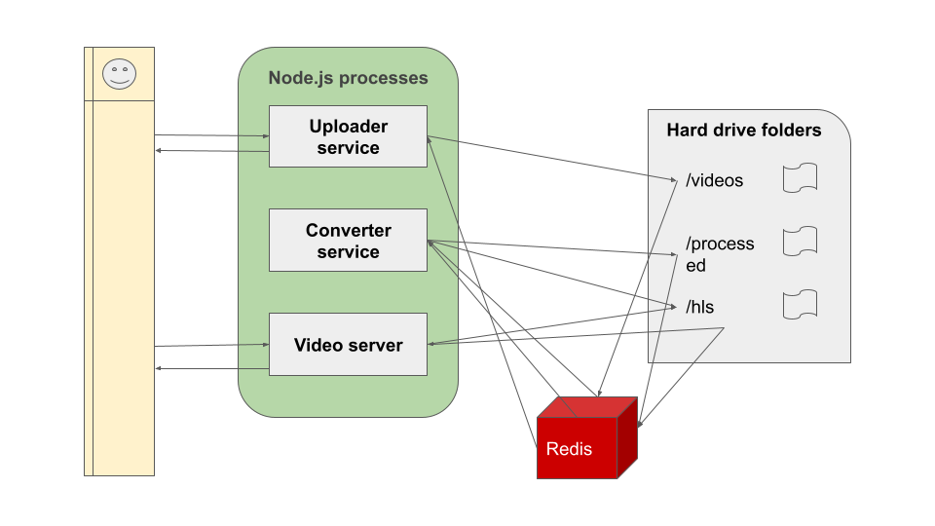Top of Form

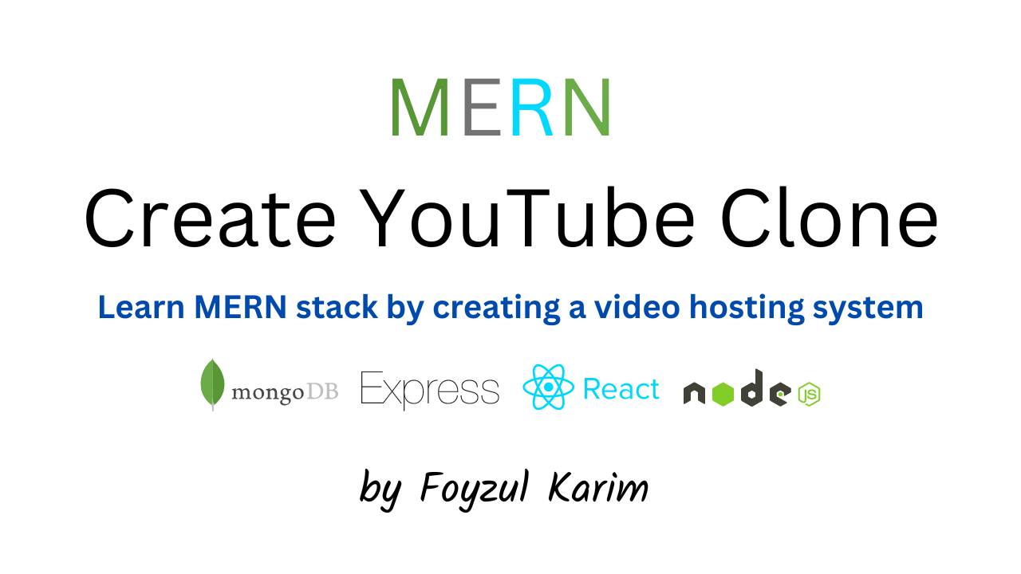



* **RESULT**:

The result of developing a video sharing app using the MERN stack encompasses various aspects, including technical functionality, user engagement, scalability, and business outcomes. Here are some key results to consider:

1. **Technical Functionality**:
   * Successful implementation of core features such as user registration, video uploading, video playback, commenting, liking, sharing, and user profile management.
   * Integration of third-party services for video processing, storage, and content delivery to ensure smooth performance and reliable streaming.
2. **User Engagement**:
   * Active user participation through interactions such as likes, comments, shares, and subscriptions, indicating high user engagement and interest in the platform.
   * User-generated content creation, including video uploads, playlists, and user-generated metadata, contributing to the growth and richness of the platform's content library.
3. **Scalability and Performance**:
   * Ability to handle increasing numbers of users, video uploads, and concurrent video streams without sacrificing performance or user experience.
   * Scalability measures such as horizontal scaling, load balancing, and caching ensuring responsiveness and reliability under heavy load.
4. **User Experience (UX)**:
   * Positive user feedback indicating satisfaction with the platform's user interface, navigation, content discovery, and playback experience.
   * Iterative improvements based on user feedback, usability testing, and UX research leading to continuous enhancement of the platform's user experience.
5. **Content Quality and Diversity**:
   * Diverse content library comprising a wide range of high-quality videos across various genres, topics, and formats.
   * Content curation mechanisms, personalized recommendations, and discovery features facilitating users in finding relevant and engaging content tailored to their preferences.
6. **Community and Social Interaction**:
   * Formation of a vibrant and active community of users, content creators, and enthusiasts around the platform, fostering social interaction, collaboration, and user-generated content.
   * Social features such as likes, comments, shares, and user interactions contributing to the sense of community and user engagement within the platform.
7. **Monetization and Business Outcomes**:
   * Successful implementation of monetization strategies such as advertising, subscription models, pay-per-view, or premium content offerings generating revenue for the platform.
   * Positive business outcomes such as increased user acquisition, retention, and revenue growth, leading to the long-term sustainability and success of the video sharing app.

Overall, the result of developing a video sharing app using the MERN stack should encompass technical excellence, positive user engagement, scalability, and tangible business outcomes, ultimately contributing to the platform's success and impact in the digital media landscape.

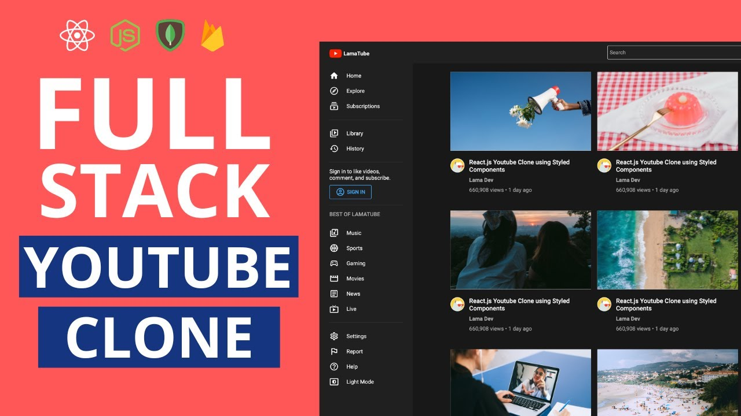

Certainly! Let's delve deeper into additional aspects of the results for a video sharing app using the MERN stack:

1. **Analytics and Insights**:
   * Implementation of analytics tools and metrics tracking to gain insights into user behavior, content performance, and platform usage patterns.
   * Utilization of analytics data to inform decision-making, optimize content recommendations, and refine user engagement strategies.
2. **Content Moderation and Safety**:
   * Implementation of content moderation mechanisms, including automated filters, user reporting systems, and manual review processes, to ensure the safety and integrity of the platform.
   * Enforcement of community guidelines and policies to prevent the spread of harmful or inappropriate content and maintain a positive user experience.
3. **Platform Customization and Personalization**:
   * Provision of customizable user settings, preferences, and recommendations to personalize the user experience and cater to individual user preferences.
   * Integration of machine learning algorithms and AI-based recommendation systems to deliver personalized content suggestions and improve user engagement.
4. **Cross-Platform Compatibility**:
   * Development of cross-platform compatibility, allowing users to access the video sharing app seamlessly across different devices and platforms, including web browsers, mobile devices, and smart TVs.
   * Implementation of responsive design principles and adaptive layouts to ensure optimal viewing experiences across a variety of screen sizes and resolutions.
5. **Community Building and Engagement Initiatives**:
   * Launch of community building initiatives, including user forums, events, challenges, and collaborations, to foster deeper engagement and connection among users and content creators.
   * Facilitation of user-generated content contests, challenges, and incentives to encourage active participation and contributions from the community.
6. **Accessibility and Inclusivity**:
   * Commitment to accessibility standards and guidelines to ensure that the video sharing app is usable and inclusive for users with disabilities.
   * Implementation of features such as closed captions, audio descriptions, and alternative text to make video content accessible to a wider audience.
7. **Continuous Improvement and Innovation**:
   * Adoption of agile development methodologies and iterative improvement cycles to continuously enhance the platform's features, performance, and user experience.
   * Investment in research and development initiatives to explore emerging technologies, trends, and innovations in the video sharing space and stay ahead of evolving user expectations.

By focusing on these additional aspects, a video sharing app using the MERN stack can achieve comprehensive results, driving user engagement, community growth, and business success in the competitive digital media landscape.

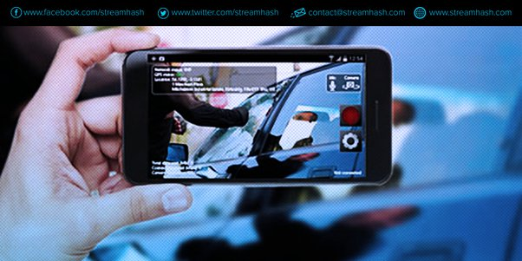

* **ADVANTAGES**:

Developing a video sharing app using the MERN stack offers several advantages that contribute to its success and effectiveness. Here are some key advantages:

1. **Full-Stack Development**: The MERN stack encompasses frontend (React.js), backend (Node.js with Express.js), and database (MongoDB) technologies, providing a comprehensive framework for building a video sharing app. This full-stack approach streamlines development, reduces complexity, and ensures seamless integration between components.
2. **Single Language**: Using JavaScript throughout the development stack simplifies the development process and reduces the learning curve for developers. With a single language for both frontend and backend development, developers can write and maintain code more efficiently, leading to faster development cycles and smoother collaboration.
3. **Real-Time Updates**: The MERN stack supports real-time communication and updates through technologies like WebSockets or server-sent events. This enables features such as live streaming, real-time commenting, and instant notifications, enhancing user engagement and interactivity within the video sharing app.
4. **Scalability**: MERN stack applications are inherently scalable, allowing them to handle increasing numbers of users, video uploads, and concurrent video streams without sacrificing performance. With horizontal scaling capabilities and cloud deployment options, MERN-based video sharing apps can grow to meet evolving user demands and traffic patterns.
5. **Rich User Interfaces**: React.js, the frontend framework of the MERN stack, enables the creation of rich, interactive user interfaces for the video sharing app. Features such as dynamic content loading, smooth animations, and responsive layouts enhance the user experience and make the app visually appealing and intuitive to use.
6. **Flexibility and Customization**: The modular nature of the MERN stack allows for flexibility and customization in developing features and functionality for the video sharing app. Developers can easily add new features, modify existing ones, and adapt the app to meet specific business requirements and user preferences.
7. **Community and Ecosystem**: The MERN stack has a large and active developer community, with abundant resources, libraries, and frameworks available for building video sharing apps. From open-source components to tutorials and forums, developers can leverage the MERN ecosystem to accelerate development, troubleshoot issues, and stay updated on best practices.
8. **Cross-Platform Compatibility**: MERN-based video sharing apps can be deployed across multiple platforms and devices, including web browsers, mobile devices, and smart TVs. With responsive design principles and cross-platform compatibility, users can access the app seamlessly from various devices, enhancing accessibility and user reach.
9. **Cost-Effectiveness**: Leveraging open-source technologies and cloud-based infrastructure, developing a video sharing app using the MERN stack can be cost-effective compared to proprietary or legacy solutions. The availability of free tools, libraries, and development resources reduces upfront costs and ongoing maintenance expenses.
10. **Rapid Prototyping and Iterative Development**: The MERN stack facilitates rapid prototyping and iterative development cycles, allowing developers to quickly build, test, and iterate on features. Agile development methodologies combined with hot reloading capabilities in React.js enable fast-paced development and efficient iteration based on user feedback and market insights.

Overall, leveraging the MERN stack for building a video sharing app offers numerous advantages, including full-stack development, single language usage, real-time updates, scalability, rich user interfaces, flexibility, community support, cross-platform compatibility, cost-effectiveness, and rapid prototyping capabilities. These advantages contribute to the success and competitiveness of MERN-based video sharing apps in the dynamic digital media landscape.

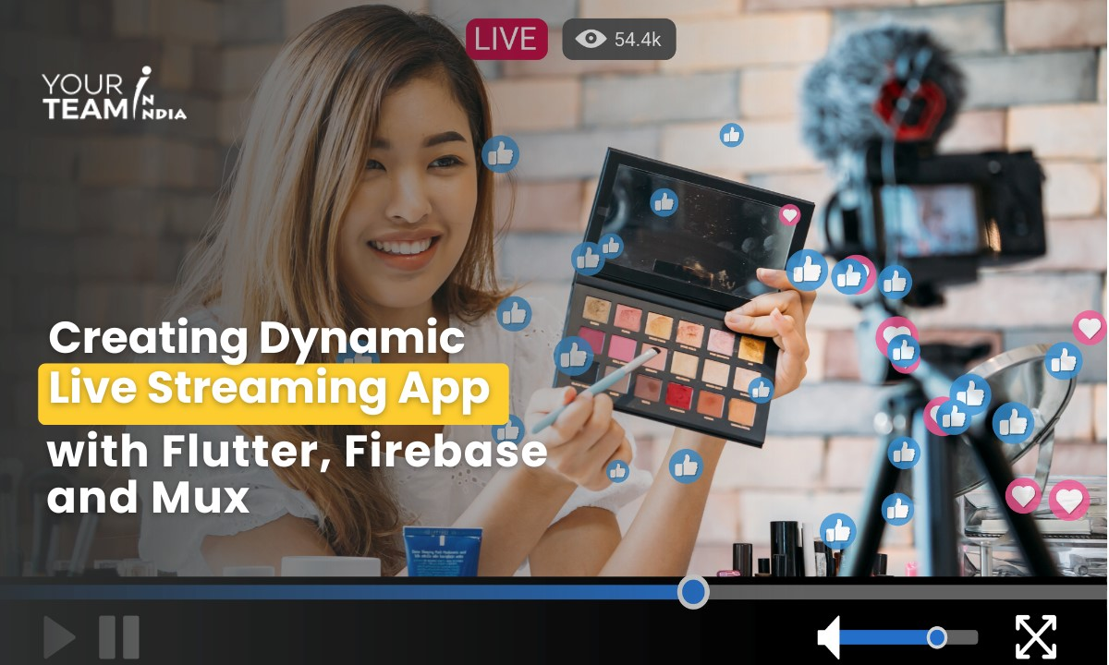



* **DISADVANTAGES**:

While building a video sharing app using the MERN stack offers numerous advantages, there are also some potential disadvantages to consider:

1. **Complexity of Development**: Developing a robust video sharing app using the MERN stack requires expertise in multiple technologies and frameworks. Managing the frontend (React.js), backend (Node.js with Express.js), and database (MongoDB) components can be complex, leading to longer development times and potential challenges in debugging and troubleshooting.
2. **Learning Curve**: For developers who are new to the MERN stack or JavaScript ecosystem, there may be a steep learning curve. Mastering the intricacies of React.js, Node.js, MongoDB, and related technologies, as well as understanding how they integrate with each other, can take time and effort, especially for inexperienced developers.
3. **Performance Considerations**: While the MERN stack can offer good performance for many applications, certain factors such as inefficient database queries, excessive client-side rendering, or lack of optimization can impact performance. Achieving optimal performance may require careful optimization, caching strategies, and performance tuning, especially for high-traffic video sharing apps.
4. **Scalability Challenges**: Scaling a video sharing app built on the MERN stack to accommodate a growing user base and increasing video uploads can present challenges. Ensuring horizontal scalability, load balancing, and efficient database sharding may require additional planning, infrastructure investment, and ongoing maintenance efforts.
5. **Security Risks**: Like any web application, MERN-based video sharing apps are susceptible to security vulnerabilities such as cross-site scripting (XSS), SQL injection, and data breaches. Implementing robust security measures, including input validation, access controls, encryption, and secure authentication mechanisms, is essential to mitigate these risks and protect user data.
6. **Dependency Management**: MERN stack applications typically rely on numerous third-party libraries, modules, and dependencies. Managing these dependencies, ensuring compatibility, and keeping them up-to-date with security patches and updates can be time-consuming and prone to dependency conflicts, potentially affecting development efficiency and stability.
7. **Vendor Lock-in**: While open-source technologies form the foundation of the MERN stack, reliance on specific libraries, frameworks, or cloud services can create vendor lock-in. Switching to alternative technologies or platforms in the future may be challenging and disruptive, particularly if the app becomes heavily dependent on proprietary services or components.
8. **Performance Overhead of JavaScript**: While JavaScript is a versatile and powerful language, it can also introduce performance overhead, especially in compute-intensive operations or large-scale applications. Optimizing JavaScript code, minimizing unnecessary computations, and leveraging server-side processing where applicable can help mitigate performance issues.
9. **Data Consistency and Integrity**: NoSQL databases like MongoDB offer flexibility and scalability but may sacrifice some aspects of data consistency and integrity compared to traditional relational databases. Ensuring data consistency, transactional integrity, and ACID compliance may require careful design and implementation, particularly for applications with complex data relationships.
10. **Regulatory Compliance**: Building a video sharing app using the MERN stack may require compliance with regulatory requirements such as copyright laws, content moderation guidelines, and data protection regulations (e.g., GDPR). Ensuring compliance with legal and regulatory standards, including user data privacy, content licensing, and intellectual property rights, is essential to avoid legal issues and reputational damage.

By carefully considering these potential disadvantages and addressing them proactively during the development process, organizations can mitigate risks and maximize the benefits of building a video sharing app using the MERN stack.

Top of Form

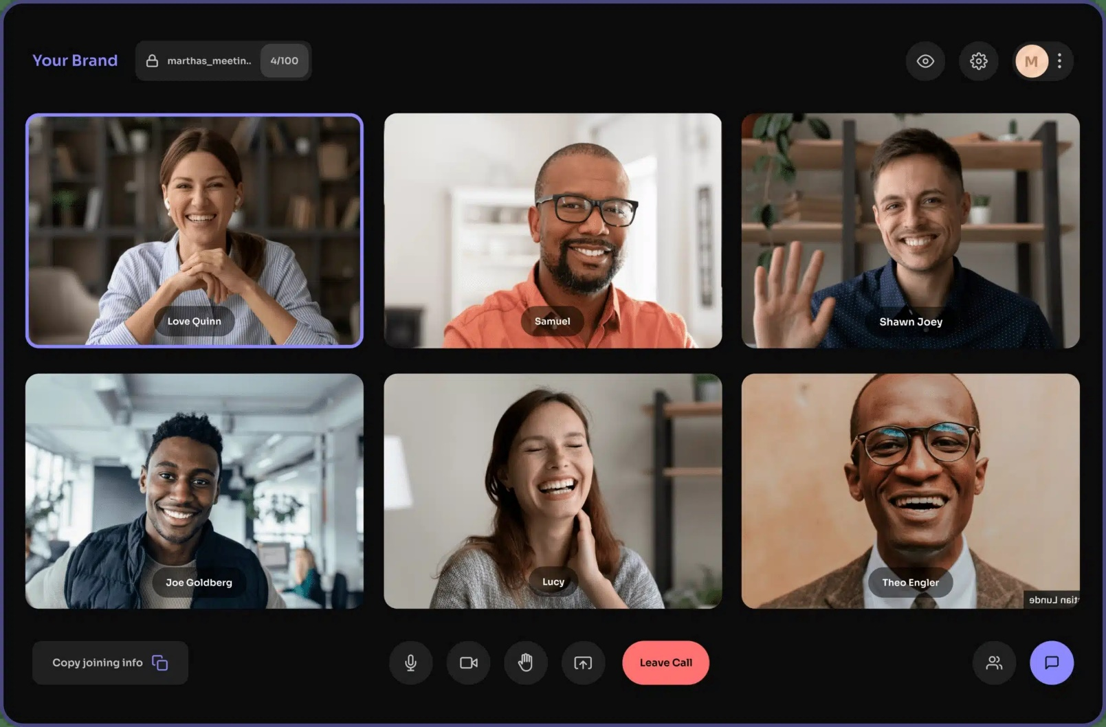

* **CONCLUSION**:

In conclusion, developing a video sharing app using the MERN stack offers a powerful and versatile solution for creating engaging, scalable, and feature-rich platforms in the digital media landscape. Throughout this journey, we've explored the various aspects, advantages, disadvantages, and considerations involved in building such an application. Let's summarize the key points:

1. **Technical Excellence**: Leveraging the MERN stack enables full-stack development with JavaScript, facilitating rapid prototyping, seamless integration, and efficient collaboration between frontend and backend teams. The use of modern frameworks like React.js, Node.js, and Express.js empowers developers to create rich, interactive user interfaces and robust backend infrastructures.
2. **User Engagement and Experience**: A well-designed video sharing app built on the MERN stack can foster high levels of user engagement through real-time updates, social interaction features, personalized recommendations, and intuitive user interfaces. Features such as likes, comments, shares, subscriptions, and content discovery mechanisms contribute to creating a vibrant and interactive community of users and content creators.
3. **Scalability and Performance**: MERN-based video sharing apps are inherently scalable, capable of handling increasing numbers of users, video uploads, and concurrent video streams without compromising performance. By implementing scalability measures, optimization techniques, and cloud-based infrastructure, organizations can ensure responsiveness and reliability under heavy load.
4. **Business Outcomes and Sustainability**: Successful implementation of monetization strategies, user acquisition, retention initiatives, and community building efforts can lead to positive business outcomes, including revenue growth, market competitiveness, and long-term sustainability. By focusing on user needs, content quality, and platform innovation, organizations can establish a strong presence in the digital media landscape and drive continued success.
5. **Challenges and Considerations**: Despite the many advantages of the MERN stack, organizations must address challenges such as complexity of development, learning curve, performance considerations, security risks, and regulatory compliance. Proactive planning, robust development practices, and ongoing monitoring and optimization efforts are essential to mitigate risks and ensure the success of the video sharing app.

In essence, building a video sharing app using the MERN stack represents a journey of innovation, creativity, and technical excellence. By harnessing the power of modern technologies, user-centric design principles, and agile development methodologies, organizations can create compelling platforms that empower users to discover, watch, and share video content seamlessly. As the digital media landscape continues to evolve, MERN-based video sharing apps are poised to play a central role in shaping the future of online video consumption and community engagement.

Top of Form